Resume Workshop hosted by ExpressJet
Create an effective resume or improve the one you already have. Transform your resume into a powerful tool that will get you interviews. Learn different resume formats and the advantages and disadvantages of each. Make the most of your work experience and discover how to use references to your advantage.

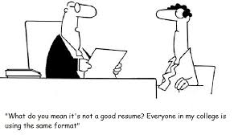

When: January 15, 2020
What: Resume Enhancement Workshop & How to be a Volunteer Workshop
Time: 11-12 pm
Who: All Guardians are welcome
Hosted by Northcutt Elementary and ExpressJet

